**HORMISDALLEN SCHOOL - KYEBANDO**

**PRE- PLE SET 4 EXAMINATIONS, 2023**

**PRIMARY SEVEN SOCIAL STUDIES**

**Duration: 2 Hours 15 Minutes**

**NAME: ______________________________________________ STREAM: _________**

INDEX NO.

EMIS NO.

**SECTION A**

1. Name any one domestic animal that is kept for milk production.

………………………………………………………………………………………………….

1. Mention one lake in Uganda well known for salt mining.

……………………………………………………………………………….……………….

1. State any one way in which a register is important to a school.

……………………………………………………………………………….……………….

1. Apart from Kenya and Tanzania, name one country of East African Community (EAC) that has a coastline.

……………………………………………………………………………….……………….

1. How is a compass useful to a pilot?

……………………………………………………………………………….……………….

1. State any one advantage of radio communication over television communication.

……………………………………………………………………………….……………….

1. State any one responsibility of a child at home.

……………………………………………………………………………….……………….

1. Name any one cash crop grown on a plantation in Uganda.

……………………………………………………………………………….……………….

1. State one reason why Sir Andrew Cohen became unpopular in Buganda kingdom.

……………………………………………………………………………….……………….

1. Why is South Western Uganda cooler than Northern Uganda?

……………………………………………………………………………….……………….

1. In which way is Uganda National Examinations Board (UNEB) contributing to the development of Education in Uganda?

……………………………………………………………………………….……………….

1. Why are people encouraged to carryout re-afforestation?

……………………………………………………………………………….……………….

1. Give one reason why Joseph Thomson is remembered in East Africa.

……………………………………………………………………………….……………….

1. Name the African Nationalist who helped to unite Zanzibar and Tanganyika to form Tanzania.

……………………………………………………………………………….……………….

1. State any one advantage of a rainy season to farmers of East Africa.

……………………………………………………………………………….……………….

1. Why did colonialists construct roads and railway lines in East Africa?

……………………………………………………………………………….……………….

1. State any one reason why a country with fast growing population should modernize its agriculture.

………………………………………………………………………………………………..

1. Why is it shorter to travel from Kampala to Entebbe by Air than by road transport?

…………………………………………………………………………………………….….

Study the weather instrument below and answer questions 19-21.

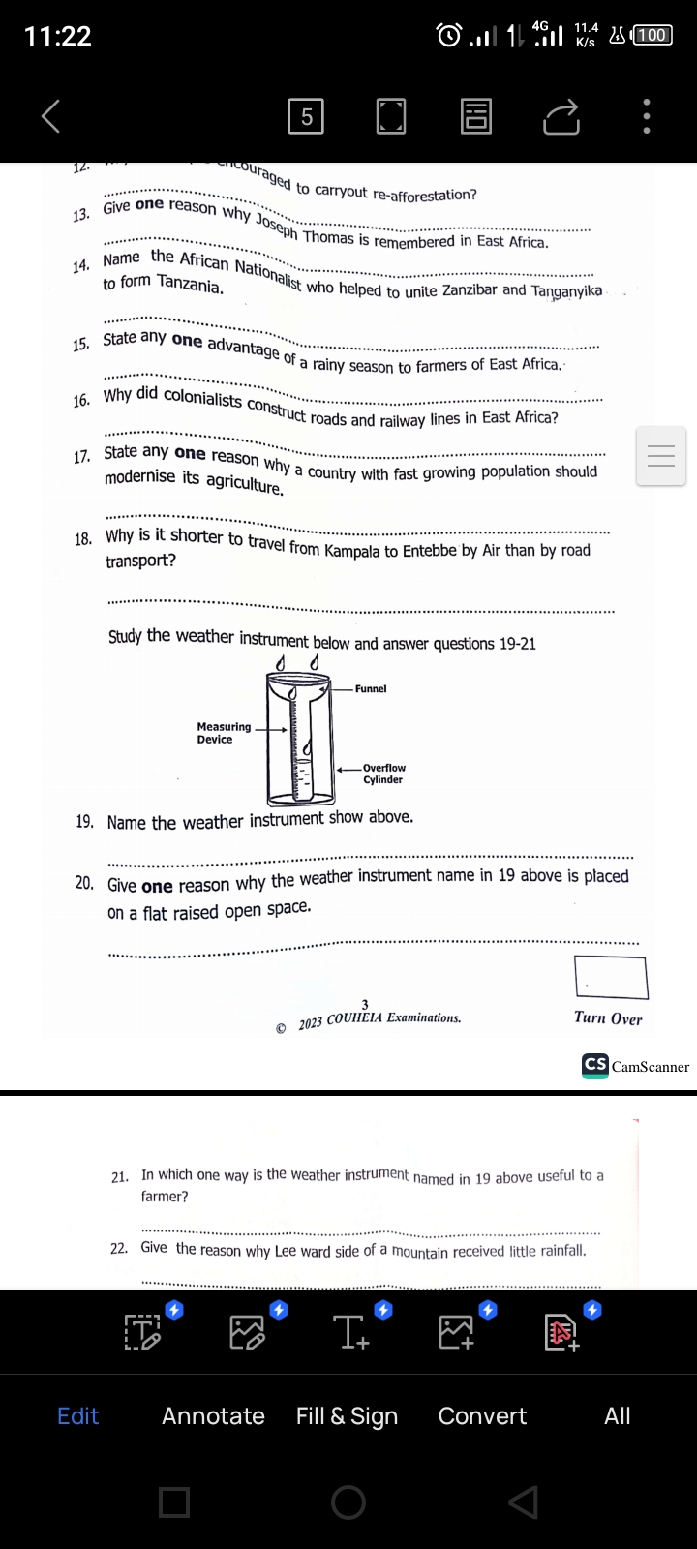

1. Name the weather instrument shown above.

…………………………………………………………………………………………….….

1. Give one reason why the weather instrument named in 19 above is placed on a flat place.

…………………………………………………………………………………………….….

1. In which one way is the weather instrument named in 19 above useful to a farmer?

……………………………………………………………………………………….…….....

1. Give the reason why Lee ward side of a mountain receives little rainfall.

……………………………………………………………………………………….……….

1. State any one reason why a busy road should have humps.

………………………………………………………………………………………….…….

1. Find the time at town K which is located 600E, if its 2:00am at Prime meridian.
2. What does the Kob represent on the Uganda Coat of Arms?

………………………………………………………………………………….…………….

1. Name the tax charged on locally manufactured goods.

…………………………………………………………………………………….………….

1. In which way does the people of Sudan benefit from River Nile?

……………………………………………………………………………….……………….

1. State one way in which the Bachwezi promoted agriculture in Uganda.

……………………………………………………………………………….……………….

1. Mention any one way in which a community can assist police to keep law and order.

…………………………………………………………………………………….………….

1. Name the climatic region in Africa that receives rainfall in winter.

…………………………………………………………………………………………….….

1. In which one way are the Fulani similar to the Karimojong?

………………………………………………………………………………………….…….

1. State any one way in which mangrove forests promote fishing industry in Africa.

…………………………………………………………………………………………….….

1. Name the best means of transporting water to homes.

…………………………………………………………………………………………….….

1. State any one way in which peace can be promoted among pupils at school.

………………………………………………………………………………………………..

1. Mention any one way in which an oasis is important to people who live in a desert.

…………………………………………………………………………………………….….

**For questions 36-40, answer Either Christianity OR Islamic questions but not both.**

1. **Either:** Apart from Isaac, name any one other child of Abraham.

………………………………………………………………………………………….…….

**OR:** Apart from Ishaq, name any one other child of Ibrahim.

………………………………………………………………………………………….…….

1. **Either:** State any one way in which the Ark was useful to Noah during the floods.

………………………………………………………………………………………………..

**OR:** State any one way in which the Ark was useful to Nuuh during the floods.

………………………………………….…………………………………………………….

1. **Either:** Write any one form of suffering to a Christian.

…………………………………………….………………………………………………….

**OR:** Write any one form of suffering to a Muslim.

………………………………………….…………………………………………………….

1. **Either:** State the commandment that protects Christian marriage from breaking up.

……………………………………….……………………………………………………….

**OR:** State any one condition under which a wife can divorce a husband.

…………………………………….………………………………………………………….

1. **Either:** Give any one reason why Christians should read the Bible.

…………………………………….………………………………………………………….

**OR:** Give any one reason why Moslems should recite the Quran.

……………………………………….……………………………………………………….

**SECTION B**

1. a) Name the mineral mined from the following areas.

i) Mwadui in Tanzania

……………………………………….……………………………………………………….

ii) Rusizi in Rwanda

………………………………………….…………………………………………………….

b) State any one way in which mining has contributed to the development of East Africa.

……………………………………….……………………………………………………….

c) Mention any one way in which mining has contributed to the development of East Africa.

……………………………………….……………………………………………………….

1. a) Mention any two traditional means of transport.

i)…………………… ……………….………………………………………………………

ii)…………………… ……………….………………………………………………………

b) State any one advantage of traditional means of transport over modern means of transport.

……………………………………….……………………………………………………….

c) Give one reason why most roads in Uganda are not tarmacked.

……………….……………….……………….……………….……………….………………

1. a) What is population distribution?

……………………………………………….……………………………………………….

b) State any two factors that determine population distribution in East Africa.

i)………………………… ……………….…………………………………………………

ii)………………………… ……………….…………………………………………………

c) Identify any one problem faced by a country that has low population.

……………………………………………………………………………….

Study the sketch map of Uganda below and answer question 44.

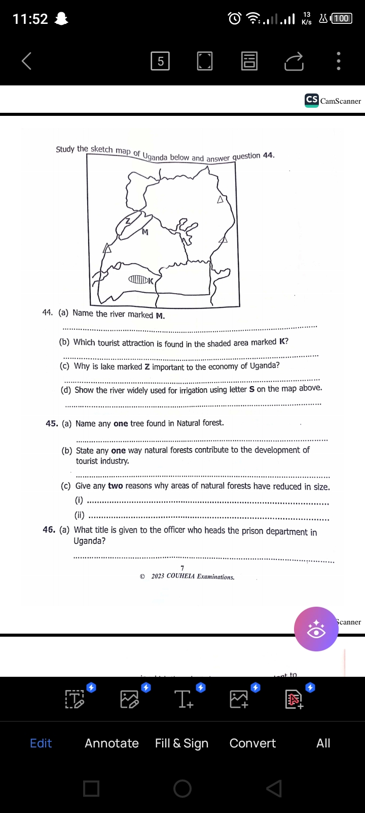

1. a) Name the river marked M.

………………………………………….…………………………………………………….

b) Which tourist attraction is found in the shaded area marked K?

..……………………………… ……………….…………………………………………....

c) Why is lake marked Z important to the economy of Uganda?

………………………………………………….…………………………………………….

d) Show Albert Nile using letter S on the map above.

………………………………………………….………………………………………….....

1. a) Name any one tree found in Natural forest.

……………………………………………….……………………………………………….

b) State any one way natural forests contribute to the development of tourism industry.

…………………………………………….………………………………………………….

c) Give any two reasons why areas of natural forests have reduced in size.

i)………………………… ……………….…………………………………………………

ii)………………………… ……………….…………………………………………………

1. a) What title is given to the officer who heads the prison department in Uganda?

…………………………………………………………………….………………………….

b) State any two ways in which the prison department is important to Uganda.

i)…………………………………………………… ……………….………………………

ii)…………………………………………………… ……………….……………………..

c) Name the ministry responsible for the prison department.

………………………………………………………………………………………………..

1. The table below shows African nationalist and their political parties. Fill in the missing information.

|  |  |
| --- | --- |
| **African Nationalists** | **Political Party** |
| Dr. Milton Obote |  |
|  | African National Congress (ANC) |
| Kwameh Nkrumah |  |
|  | Kenyan African National Union (KANU) |

1. a) Name the river that drains the largest part of Democratic Republic of Congo.

………………………………………………………………………….…………………….

b) State any two reasons why the river named in (a) above carries the largest volume of water to the sea.

i) ..………………………………………………… ……………….………………………....

ii) ………………………………………………………………….………………………….

c) Name the mouth of the river named in (a) above.

…………………………………………………………………….………………………….

1. Study the sketch map of Africa below and answer the question 49.

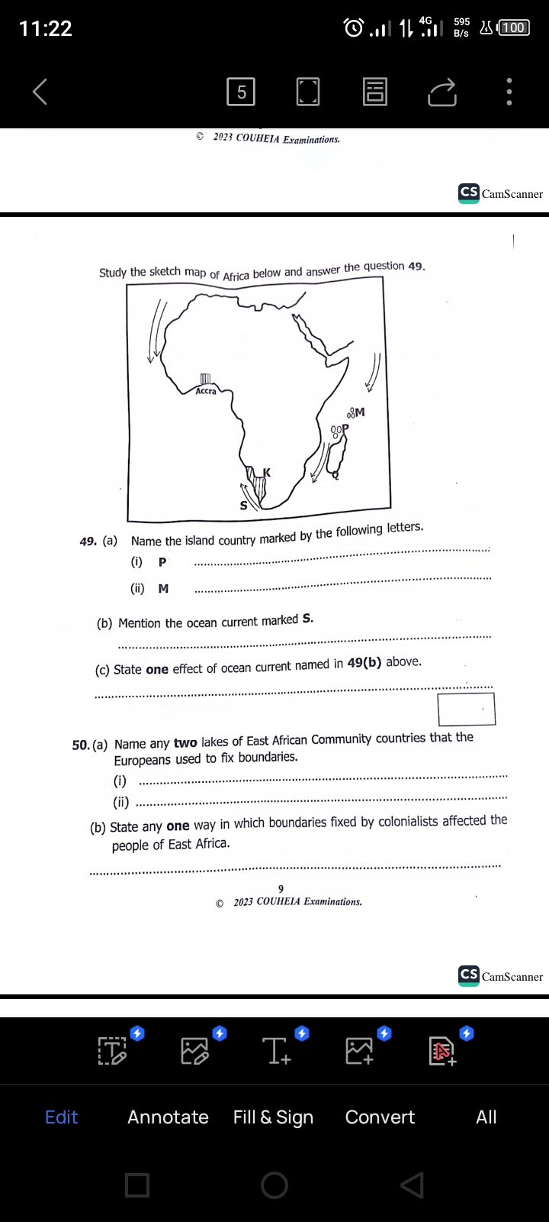

a) Name the island county marked by the following letters.

i) P………………………………………………………….………………………………....

ii) M……………………………………………………….………………………………….

b) Mention the ocean current marked S.

………………………………………………………….………………………………….

c) State one effect of ocean current named in 49(b) above.

……………………………………………………………………………….

1. Name any two lakes of East African Community that the Europeans used to fix boundaries.

i)…………………………………………… ……………….……………………………..

ii)………………………………………… ……………….……………………………….

b) State any one way in which boundaries fixed by colonialists affected people of East Africa.

………………………………………………………………….……………………….....

c) Mention one main reason why African leaders have maintained the boundaries fixed by colonialists.

……………………………………………………………….…………………………….

**For questions 51-55, answer EITHER Christianity OR Islamic questions but not both.**

1. **Either:** a) Name any one of the apostles of Jesus.

………………………………………………………………….………………………….....

b) Give any one reason why Jesus had apostles.

………………………………………………………………….………………………….....

c) State any two similarities between church leaders of the church today and the apostles of Jesus Christ.

i) …………………………………………………………….…………………………….....

ii) …………………………………………………………….…………………………….....

**OR:** a) Name any one companion of Prophet Muhammad. (PBUH)

………………………………………………………………….………………………….....

b) Give any two reasons why Prophet Muhammad had a companion.

i) ……………………………………………………………….………………………….....

ii) ……………………………………………………………….………………………….....

c) State any one similarity between Muslim leaders of today and the caliphs of Prophet Muhammad (PBUH)

…………………………….………………………………….………………………………

1. **Either:** a) State the origin of death according to the Bible.

………………………………………………………………….………………………….....

b) Mention the place faithful Christian believers will go after judgment day.

………………………………………………………………….………………………….....

c) Write two ways Christians honour the dead.

i) ……………………………………………………………….………………………….....

ii) ……………………………………………………………….………………………….....

**OR:** a) State the origin of death according to the Quran.

………………………………………………………………….………………………….....

b) Mention the place faithful Muslim believers will go after judgment day.

…………………………………………………………………….………………………...

c) Write two ways Muslims honour the dead.

i) ……………………………………………………………….………………………….....

ii) …………………………………….…………………………………………………….....

1. **Either:** a) State any one cause of misunderstandings among Christians

**…**..……..……………………………………….……………………………………………

b) Mention two ways Christians reconcile with one another.

1. ………..……………………………………………………….……………………………
2. …………………..………………………………………………….………………………

c) How is reconciliation of Christians similar to African Traditional Religion (ATR) reconciliation?

………………………………………………………………………….…………………….

**OR:** a) State any one cause of misunderstandings among Muslims.

**…**..……..……………………………………………………………….……………………

b) Mention two ways Muslims reconcile with one another.

1. ………..…………………………………………………………….………………………
2. …………………..………………………………………………….………………………

c) How is reconciliation of Muslims similar to African Traditional Religion (ATR) reconciliation?

………………………………………………………………………….…………………….

1. **Either:** a) State two activities Jesus performed on Holy Thursday.
2. ………..…………………………………………………………….………………………
3. …………………..………………………………………………….………………………

b) What do the following represent during the Holy Communion?

i) Bread……………………………………………………………….……………………..

ii) Wine………………………………………………………………….…………………..

**OR:** a) State the pillar of Islam that brings the rich and the poor together.

…………………………………………………………………………….………………….

b) Name the two types of the pillar named in (a) above.

1. ………..………………………………………………………………….…………………
2. …………………..……………………………………………………….…………………

c) Why do Muslims pray?.

………..………………………………………………………………….…………………

1. **Either:** a) Match the given information in list A to that in list B correctly.

|  |  |
| --- | --- |
| **A** | **B** |
| 1. Isaiah | Endured suffering |
| 1. Mary Magdalene | Buried Jesus Christ |
| 1. Job | Preached about the coming of Jesus |
| 1. Joseph of Arimathes | Was the first to see Jesus after resurrection. |

1. Isaiah ……………………………………………………………………
2. Mary Magdalene…………………………………………………………
3. Job…………………S………………………………………………
4. Joseph of Arimathes……………………………………………………

**OR:**

a) Who is a prophet?

………..………………………………………………………………….…………………

b) Mention any two prophets in Islam.

1. ………..…………………………………………………………….………………………
2. …………………..………………………………………………….………………………

c) State any one role of prophets in Islam.

………..………………………………………………………………….…………………

**\*\*\*END\*\*\***